RIYA KUMARI

|  |  |
| --- | --- |
| **Miscellaneous Details** | |
| Class | III |
| School | Gayatri Siksha Niketan |
| Board | Central Board of Secondary Education |
| Medium of Instruction | Hindi |

**FINANCIAL EXPENSES**

|  |  |  |
| --- | --- | --- |
| **Expenditure on** | **Cost** | **Total Cost** |
| Admission fee | Rs. 2100 paid at the start of session | Rs. 2100/- |
| Monthly tuition fee | Rs. 550 per month for 12 months | Rs. 6600/- |
| Transportation charges | Rs. 350 per month for 12 months | Rs. 4200/- |
| Purchase of books | Rs. 1500 paid at the start of session | Rs. 1500/- |
| Purchase of stationery | Rs. 1000 for whole year | Rs. 1000/- |
|  | **Overall expenses per annum** | Rs. 15,400/- |
|  | **Average expenditure per month** | Rs. 1284/- |

**ACADEMIC RESULT OF THE PREVIOUS CLASS ATTENDED**

Side-1

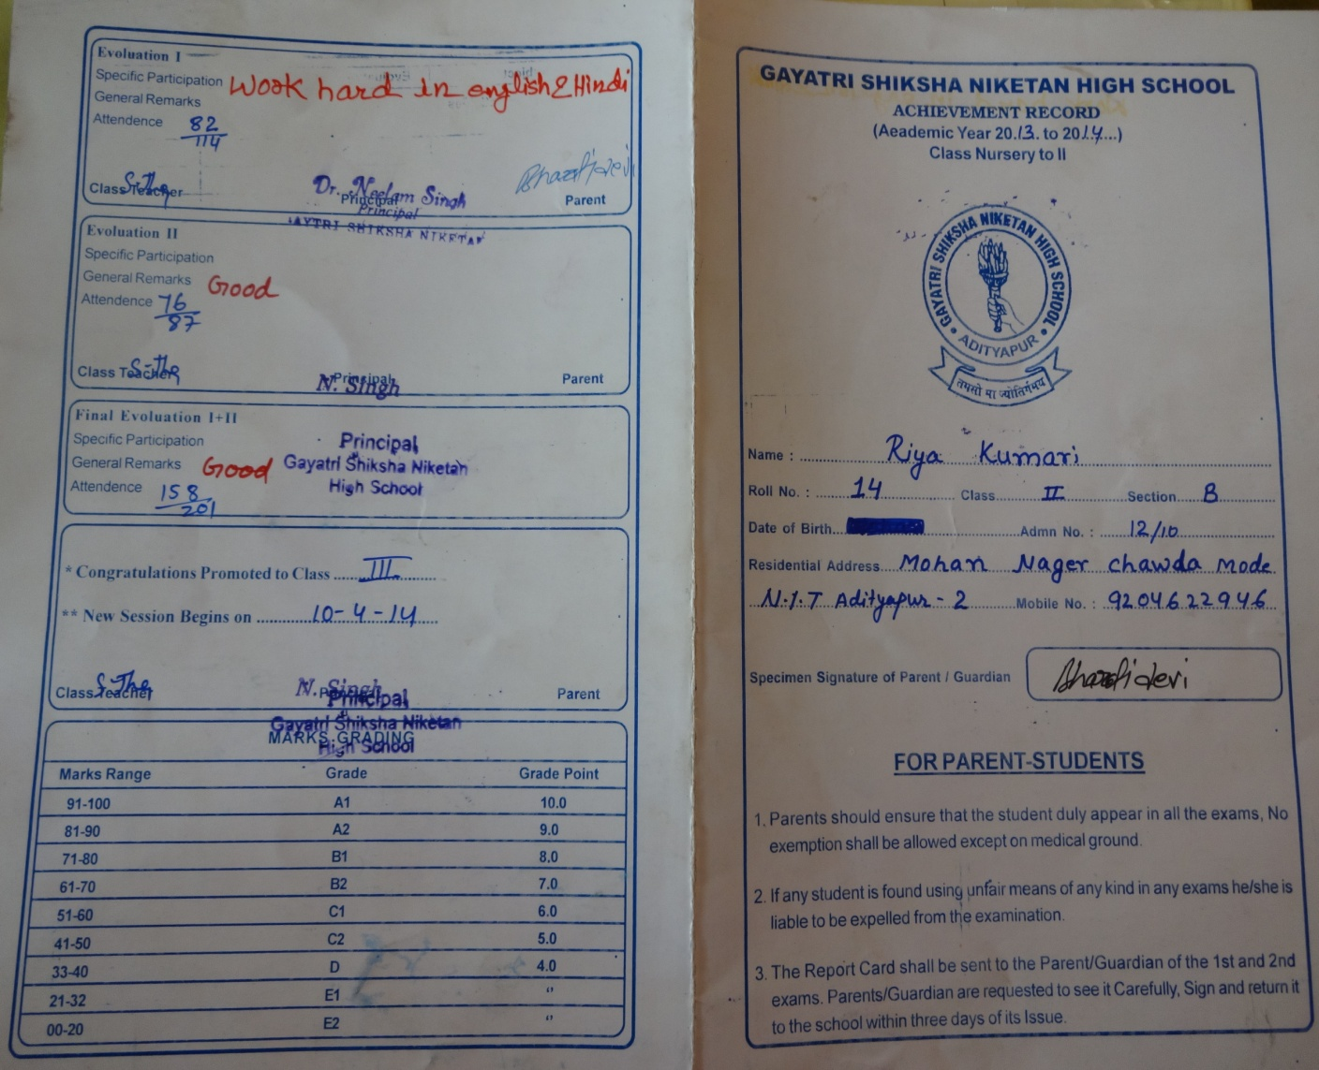

Side-2

